Level 7 -> Level 8

The goal of this level is to read the content of **data.txt** file and get the password which is next to the word **millionth** for next level.

Using **cat** command, we can easily display the content of **data.txt** file, but it contains many different words and corresponding password. Password which is useful for us is next to the word **millionth.**

Here, **grep** command is useful for us. The **grep** filter searches a file for a particular pattern of characters, and displays all lines that contain that pattern. It allows us to **find** and print the results for whole **words** only. To **search for** a particular **word** in all **files** in the current directory, append –w to the **grep command**.

So, to search for word millionth we can use command as: **grep -w millionth data.txt**

Password for next level is next to this word.

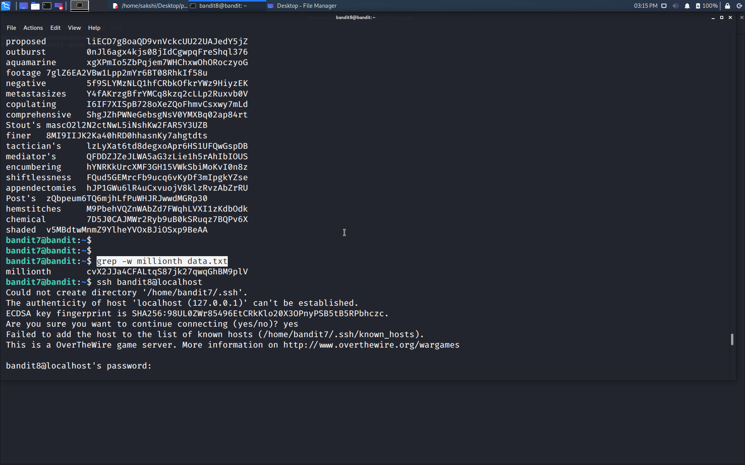

Use the command **ssh bandit8@localhost** to connect to the level 8.

Enter the password and hit enter.

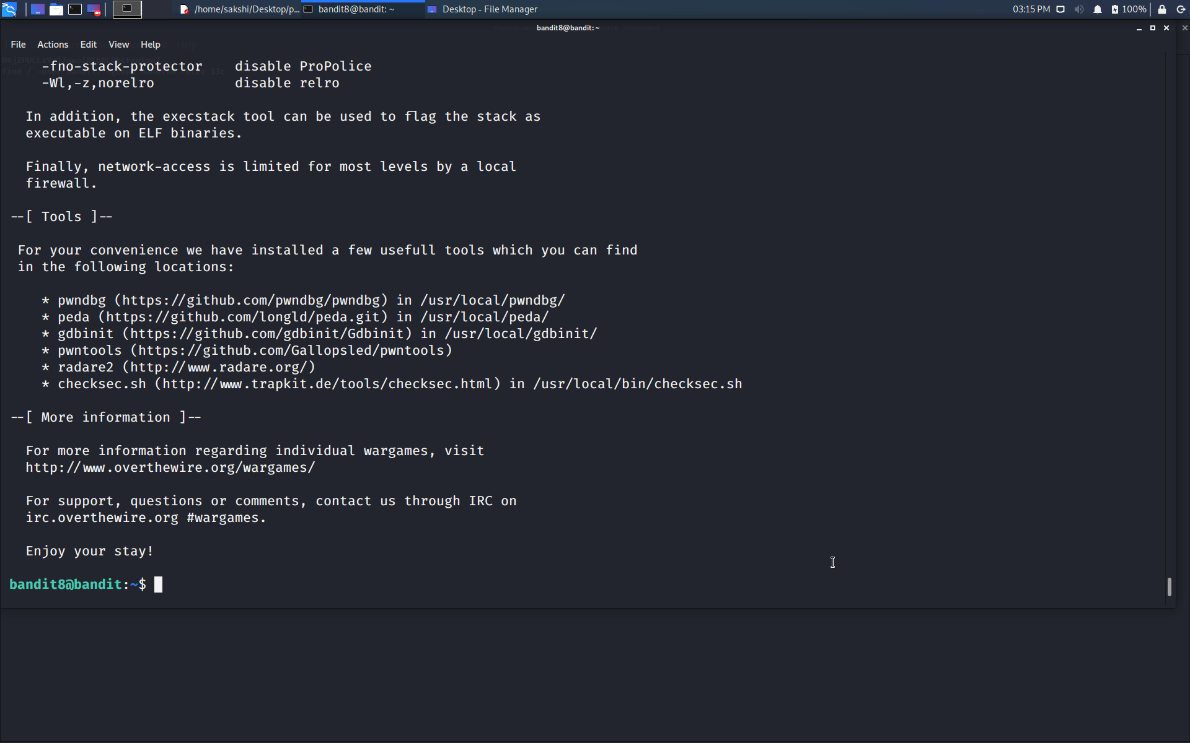

Successfully passed level 8.…